Web Engineering


Complex Computing Problem Report

Submitted By:
Aryan Shahid (RC-479)
Owais Malik (RC-484)
BSCS 5th Semester

Submission Date: 13th December, 2025
Submitted To: Sir Emad Amjad

Department of Computer Science
Open Ended Lab (OEL) / Complex Computing Problem (CCP) Report
Project Title: Infinity E-Commerce Solution

- Introduction:
The Infinity E-Commerce Solution is a modern, full-stack web application designed to simulate a real-world online shopping experience. Developed as an Open Ended Lab (OEL) project, it integrates cutting-edge web technologies to solve the complex problem of creating a seamless, responsive, and interactive e-commerce platform.
The primary objective was to bridge the gap between frontend interactivity and backend reliability. By leveraging React 19 for the user interface and a Node.js/Express architecture for the server, the application demonstrates a mastery of full-stack development principles. Key features include dynamic product browsing, real-time search filtering, a persistent shopping cart managed via global state, and a robust checkout process with automated email notifications.

- System Architecture:
The system is built upon a Client-Server Architecture, utilizing the REST architectural style for communication. The backend adopts the MVC (Model-View-Controller) design pattern to ensure code modularity, scalability, and ease of maintenance.
Architectural Component Breakdown
- Presentation Layer (Frontend): Built with React 19, it utilizes Functional Components and Hooks (useState, useEffect, useMemo) for logic. React Router DOM handles client-side routing, providing a Single Page Application (SPA) feel.
- Application Layer (Backend): Hosted on Node.js with Express.js. It serves as the entry point for API requests, routing them to appropriate controllers.
- Data Layer (Database): PostgreSQL is employed as the relational database management system to store structured product data.
- Service Layer: Nodemailer is integrated as a micro-service for handling asynchronous email communications.

System Architecture Diagram:
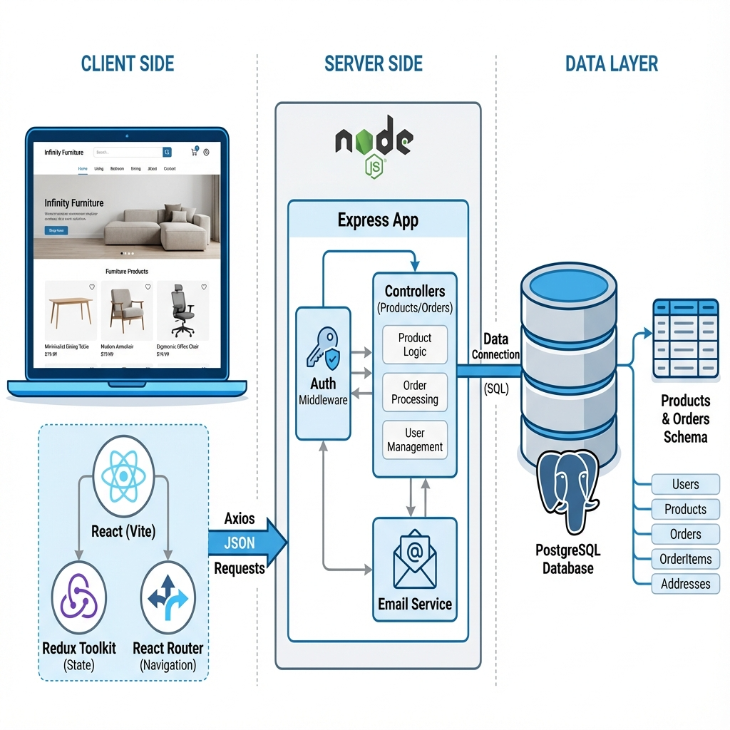

- API Endpoints Specification:

Method | Endpoint | Description | Controller
GET | /api/products | Retrieves the full catalog of products. Used to populate the Shop and Home pages. | productController.js
POST | /api/send-confirmation | Accepts order details (customer info, cart items), logs the transaction, and triggers confirmation emails to both the customer and admin. | orderController.js
POST | /api/subscribe | Accepts an email address and sends a "Welcome" newsletter email. Used in the Footer component. | newsletterController.js
POST | /api/contact | Processes contact form submissions, forwarding the user's message, subject, and details to the administration team. | contactController.js

- State Management Strategy:
Effective state management is critical for e-commerce applications to maintain data consistency (e.g., cart count) across different views. "Infinity" employs a hybrid strategy:
A. Global State (Redux Toolkit)
Redux Toolkit is used to manage application-level state that must persist across route changes.
- Store Configuration: Centralized store combining reducers.
- Cart Slice (cartSlice.js):
  - State: Tracks cartItems array, totalQuantity, and isSidebarOpen.
  - Actions: addToCart, removeFromCart, toggleCart, clearCart.
Significance: This ensures that when a user adds an item on the "Home" page, the "Navbr" cart badge updates immediately, and the item is visible in the "CartSidebar" regardless of navigation.
B. Local State (React Hooks)
Standard React hooks are used for UI-specific, ephemeral state.
- useState: manages form inputs (Checkout, Contact), loading statuses, and visibility toggles.
- useMemo: Used in the Navbar Search to cache filtered results. This optimizes performance by preventing re-calculation of the product list on every keystroke unless the search term changes.
- useLocation: Used to force re-rendering of animations on route changes.

- Challenges & Creative Solutions:
Challenge 1: Asynchronous Feedback
- Problem: Users were unsure if their Checkout or Subscription requests were processing, leading to potential double-submissions.
- Solution: Implemented a Global Loading Overlay. This custom component creates a glass-morphism effect over the entire screen with a "Processing..." pulse and an infinite spinner. It is triggered by awaiting async API calls in the frontend components.
Challenge 2: Dynamic Animations
- Problem: Standard CSS animations only ran once on initial load.
- Solution: Integrated the AOS (Animate On Scroll) library. To ensure the Navbar "fade-down" animation played specifically on navigation events, we keyed the Navbar component with the current route path (key={location.pathname}), forcing React to re-mount it and re-trigger the animation lifecycle.
Challenge 3: Backend Scalability
- Problem: A monolithic server.js file became difficult to manage as new features (Contact, Newsletter) were added.
- Solution: Refactored the backend into a strict MVC Directory Structure. Code was split into routes/ (definitions), controllers/ (logic), services/ (email), and config/ (database), adhering to industry best practices for separation of concerns.

- Screenshots of UI Pages:

- Figure 1: Home Page - Showcasing the Hero section and Hotspots.



- Figure 2: Displaying product grid and sorting mechanism.

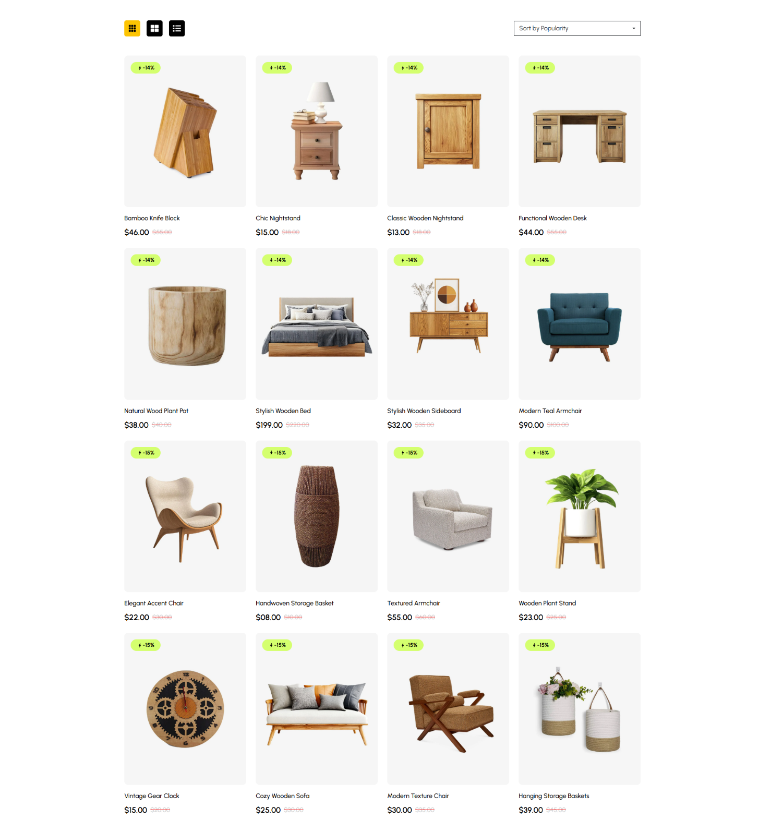

- Figure 3: Checkout Flow - The Checkout form and subsequent Email Confirmation.
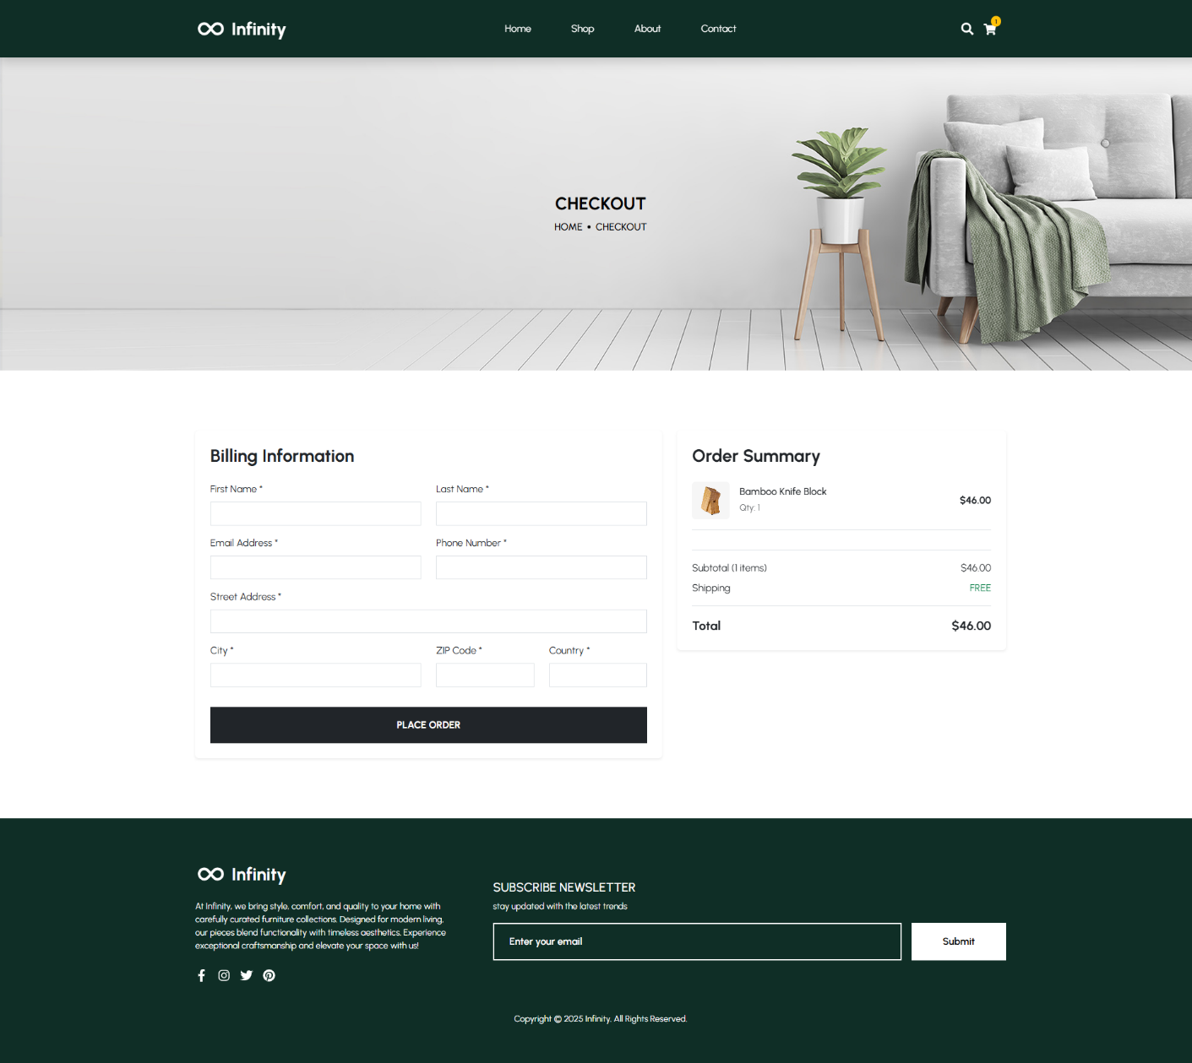
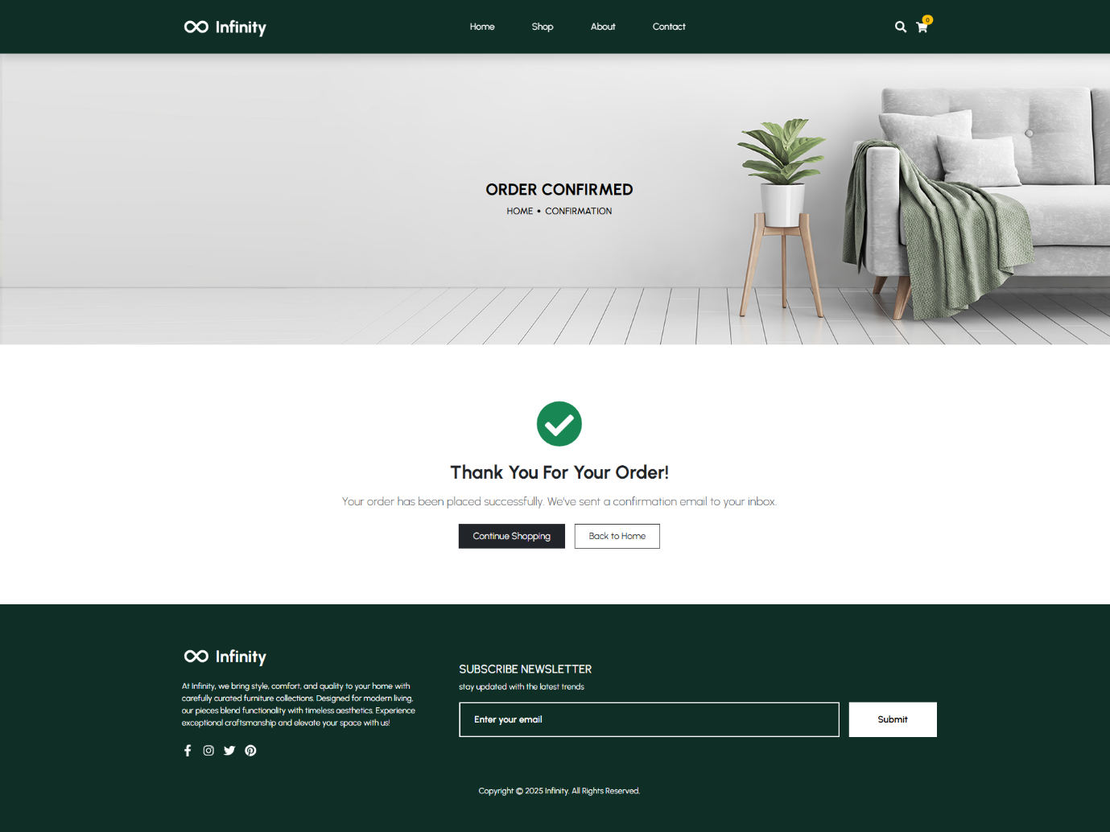

- Conclusion:
The "Infinity" project successfully meets the requirements of the Complex Computing Problem. It demonstrates a deep understanding of full-stack interoperability, effectively connecting a React 19 frontend with a Node.js backend. The inclusion of Redux for state management, along with professional touches like the Loading Overlay and email integration, elevates the user experience beyond a basic prototype. This project serves as a comprehensive example of modern web engineering practices, handling everything from database connectivity to frontend animation dynamics.

- References:

- React Documentation. (2024). React Reference Overview. Retrieved from https://react.dev/
- Redux Toolkit. (2024). Redux Toolkit: The Official, Opinionated, Batter-Included Toolset for Efficient Redux Development. Retrieved from https://redux-toolkit.js.org/
- Express.js. (2024). Fast, unopinionated, minimalist web framework for Node.js. Retrieved from https://expressjs.com/
- AOS - Animate On Scroll. (2024). AOS Library. Retrieved from https://michalsnik.github.io/aos/
- Nodemailer. (2024). Nodemailer Module for Node.js. Retrieved from https://nodemailer.com/

- Git Repository Link:
https://github.com/mr-2aryan/Infinity

THE END

